SCSI TOOLBOX, LLC
Preparing your system for STB Suite v8.1

Contents
Updating your USB Key (Dongle) 3
Step 1 – unzip all installation files. 3
Step 2 - Installing the latest Aladdin SRM Runtime driver package 3
In Case of any errors at this point – please go to Appendix A 3
Step 3 - Checking your SRM installation 3
Step 4 – Installing STB Package information to your key – Part 1 4
Step 5 - Installing STB package information to your key – Part 2 7
Step 6 - Applying Performa information to your key – Part 1 9
Step 7 - Installing STB Package information to your key – part 2 10
Appendix A – SRM Runtime Install errors 11

Updating your USB Key (Dongle)

Several steps are required to update your STB USB license key to prepare for installation of the new STB Suite version 8.1. These steps will be outlined below – it is very important that these steps be executed in the exact order described. Doing so will insure uninterrupted use and open up access to all the new features of version 8.1

Step 1 – unzip all installation files.
- Unzip the files ““STBSuitev81.exe” and “STBCustomerKeyUpdateVer81.exe”

Step 2 - Installing the latest Aladdin SRM Runtime driver package
- Go to ftp://ftp.aladdin.com/pub/hasp/srm/Runtime_%28Drivers%29/HASP_SRM_Runtime_setup.zip
- Install this package following all on-screen instructions

In Case of any errors at this point – please go to Appendix A

Step 3 - Checking your SRM installation
- Point your web browser to http://localhost:1947
- You should see the Aladdin Admin Control Center (ACC) displayed. If you do not see the ACC go back to step 1 and insure that you have properly installed the SRM runtime package
- Be sure that your STB USB key (dongle) is plugged in to a USB port and that its red LED it lit.
- In the ACC click on the HASP Keys choice under Administration Options at the left of the screen.
- You should see something like this, showing your key information:
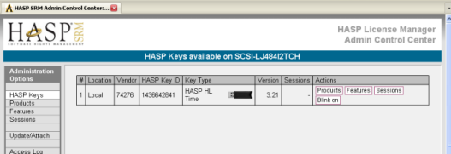

- Write down the HASP Key ID number
- Note that the Version is 3.20 or above. If it is not please contact support@scsitoolbox.com
- Note that the Key Type is a HASP HL Time or HASP HL Net. If it is not please contact support@scsitoolbox.com

Step 4 – Installing STB Package information to your key – Part 1
- Run the program “STBSuitev81.exe”
- You will see this screen:
- 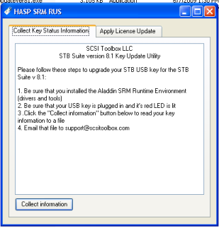
- Click the “Collect Information” button
- Tell the program where to create your update file
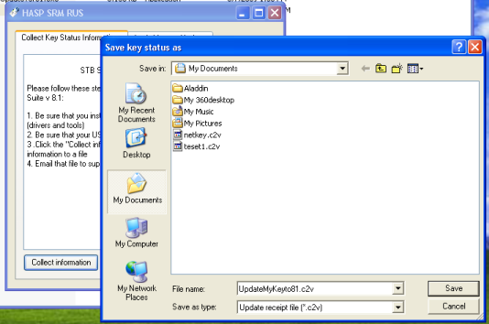
You should see a message indicating success like this:
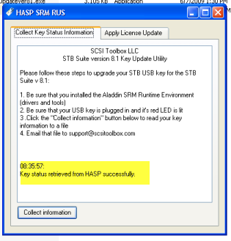
- Email the file you just created to support@scsitoolbox.com
- In the body of the email where you send this file please record the HASP Key ID number which you wrote in step 1
- when you receive your SRM update file back from STB support continue to step 5

Step 5 - Installing STB package information to your key – Part 2
-when you receive the return email from support save the attached update file into the folder where the program “STBSuiteV81.exe” resides
- run “STBSuiteV81.exe” again
- Click the “Apply License Update” tab, and then use the browse button to locate your update file
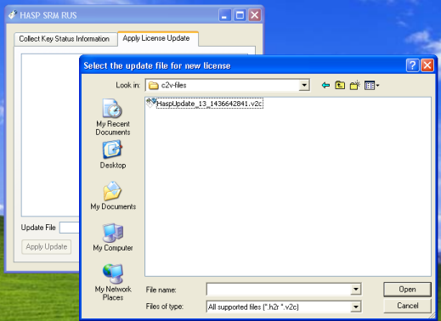

- Click “Apply Update” and you should see an indication of success like this:
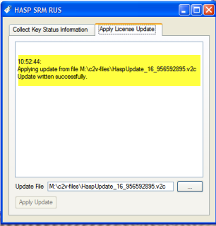

Step 6 - Applying Performa information to your key – Part 1
- Now start the STB Performa key update program by double-clicking on “STBCustomerKeyUpdateVer81.exe”
- You will see this screen:
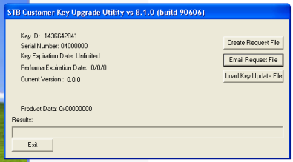

- Click on “Create Request File” – and the screen will change to
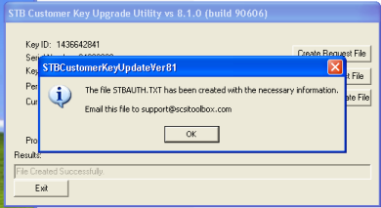

- Email the file “STBAuth.txt” to support@scsitoolbox.com.
- Exit the STBSuiteV81.exe program
- When you receive your Performa Key Update file from STB Support continue to step 7

Step 7 - Installing STB Package information to your key – part 2
- Save the update file returned to you from STB Support
- Restart the program STBCustomerKeyUpdateVer81.exe”
- Click the button “Load Key Update File”, and use the browse feature to point to your update file which was just sent to you from support.
- You should see this screen:
- 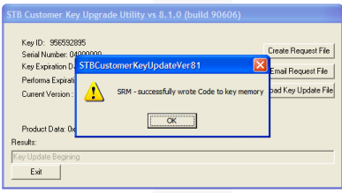
- Click “OK” and you should now see your valid Serial Number, Performa date and version information like this:
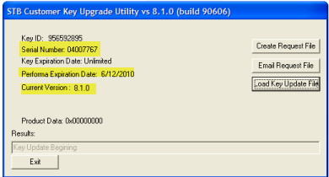
- If you do not see a screen indicating success please contact support@scsitoolbox.com

If all of the above steps have been successfully executed then you are now ready to install the STB Suite version 8.1

Appendix A – SRM Runtime Install errors

If while installing the SRM Runtime Driver package you receive any of these errors indicating that previous versions of the Aladdin drivers are preventing installation of the SRM Runtime package:
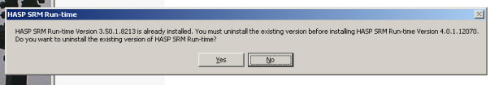

Or

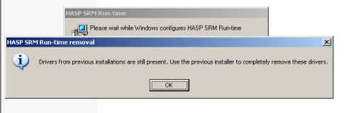
You will need to take the following steps to remove the previous version(s):

- Use Control Panel -> Add-Remove Programs
- uninstall any HASP or Aladdin programs such as shown here:
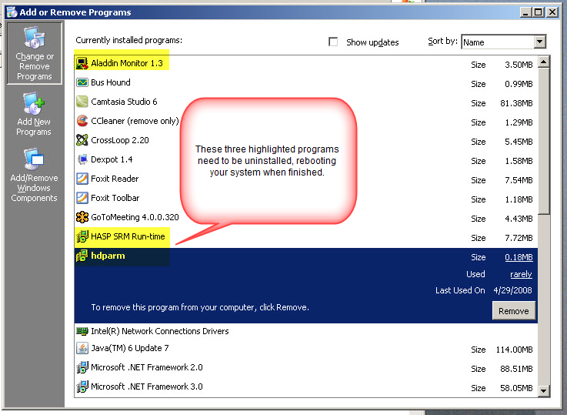
After rebooting your system try to install the SRM Runtime package again. If you still get a message about old drivers proceed to step 2 below
- Manually remove old drivers
- Open a command prompt window (Start->Run.>Cmd) and navigate to your STB default folder, then type “hinstall.exe –r” to remove one old driver –
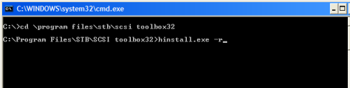
Then type “haspdinst.exe –fremove” as shown here:
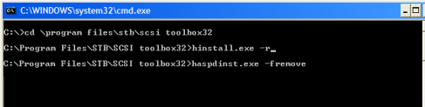
Now you should be able to complete the SRM Runtime installation

